YORK KSA Mobile Application Customer Journey Samples:

Introductory Animated Visual



Selection Page (Services / Online Store)

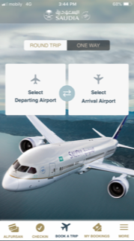

Menu Tab Look and feel

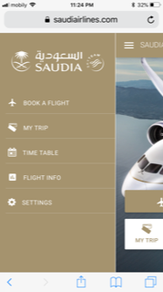

Online Store Header

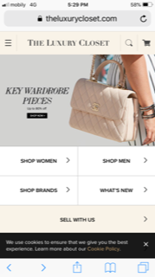

Service Tracking

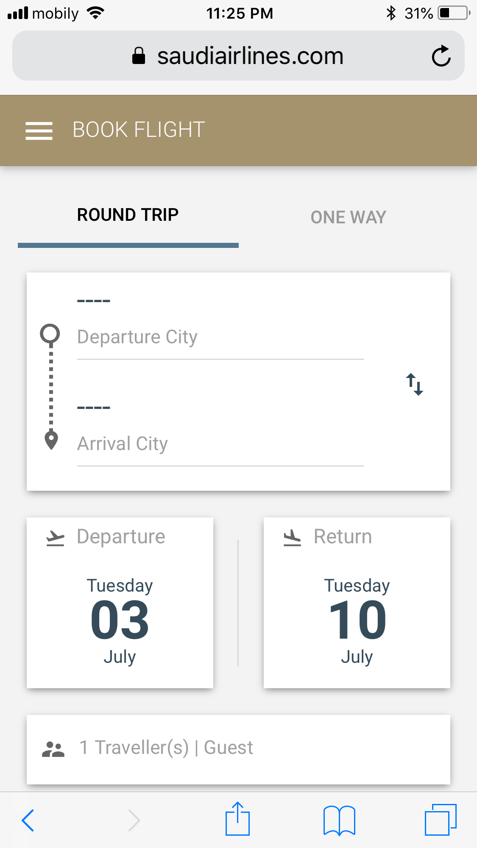

Immediate location using YORK Guide l Satisfaction emojis can be used for After Services Survey)

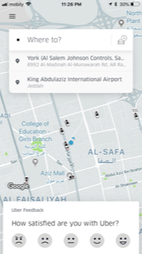

Submit service request

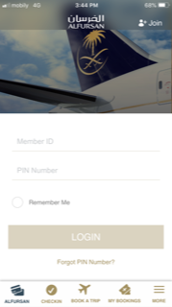

Login page layout (if finger print can be included as well)

